OS LAB 8

2022-CS-36

1.

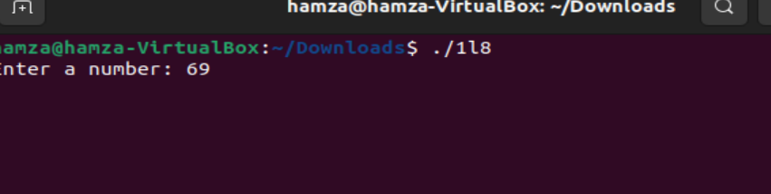

2.

3.

